**Semester Two Examination 2019**

**Question/Answer Booklet**

**NAME:**

**HUMAN BIOLOGY**

**ATHBY Unit 3 & 4**

**Teacher:** ______________________________________

|  |  |  |  |  |  |  |  |
| --- | --- | --- | --- | --- | --- | --- | --- |
|  |  |  |  |  |  |  |  |

**Student number**  **In figures:**

**In words:** ______________________________

______________________________

**Time allowed for this paper**

Reading time before commencing work: 10 minutes

Working time: 3 hours

**Materials required/recommended for this paper**

***To be provided by the supervisor***

This Question/Answer booklet

Multiple-choice answer sheet

***To be provided by the candidate***

Standard items: pens (blue/black preferred), pencils (including coloured), sharpener, eraser, correction fluid/tape, ruler, highlighters

Special items: non-programmable calculators approved for the use in this examination

**Important note to candidates**

No other items may be taken into the examination room. It is **your** responsibility

to ensure that you do not have any unauthorised notes or other items of a non-

personal nature in the examination room. If you have any unauthorised material with

you, hand it to the supervisor **before** reading any further.

**Structure of this paper**

|  |  |  |  |  |  |
| --- | --- | --- | --- | --- | --- |
| Section | Suggested working time | Number of questions available | Number of questions to be attempted | Marks | Percentage |
| SECTION ONE:  Multiple-choice | 40 minutes | 30 | All | 30 | 30 |
| SECTION TWO:  Short answers | 90 minutes | 9 | All | 100 | 50 |
| SECTION THREE:  Extended answers | 50 minutes | 3 | 2 | 40 | 20 |
|  |  |  | Total marks | 170 | 100 |

**Instructions to candidates**

1. The rules for the conduct of the Western Australian Certificate of Education ATAR course examinations are detailed in the Year 12 Information Handbook 2019. Sitting this examination implies that you agree to abide by these rules.
2. Write your answers in this Question/Answer booklet preferably using a blue/black pen. Do not use erasable or gel pens.
3. Answer the questions according to the following instructions.

Section One: Answer all questions on the separate Multiple-choice answer sheet provided. For each question, shade the box to indicate your answer. Use only a blue or black pen to shade the boxes. If you make a mistake, place a cross through that square then shade your new answer. Do no erase or use correction fluid/tape. Marks will not be deducted for incorrect answers. No marks will be given if more than one answer is completed for any question.

Section Two: Write your answers in this Question/Answer booklet. Whenever possible, confine your answers to the line spaces provided.

Section Three: Consists of three questions. You must answer two questions.

Tick the box next to the question you are answering. Write your answers in this Question/Answer booklet.

1. You must be careful to confine your answers to the specific questions asked and to follow any instructions that are specific to a particular question.
2. Supplementary pages for planning/continuing your answers to questions are provided at the end of this Question/Answer booklet. If you use these pages to continue an answer, indicate at the original answer where the answer is continued, i.e. give the page number.

**Section One: Multiple-choice 30% (30 marks)**

This section has **30** questions. Answer **all** questions on the separate Multiple-choice answer sheet provided. For each question shade the box to indicate your answer. Use only a blue or black pen to shade the boxes. Do not use erasable or gel pens. If you make a mistake, place a cross through that square, then shade your new answer. Do not erase or use correction fluid/tape. Marks will not be deducted for incorrect answers. No marks will be given if more than one answer is completed for any question.

Suggested working time: 40 minutes.

________________________________________________________________________

1. Hypothyroidismis best treated with
2. radioactive iodine.
3. a thyroidectomy.
4. insulin.
5. thyroxine replacement.
6. Which of the following correctly defines the effector as part of a negative feedback system?
7. The effector is responsible for carrying out the response.
8. The effector detects the change in the environment.
9. The effector coordinates the response.
10. The effector ensures that the response is enhanced.
11. The adrenal cortex is responsible for secreting
12. adrenaline and noradrenaline.
13. aldosterone and cortisol.
14. testosterone and oestrogen.
15. insulin and glucagon.
16. Which of the following statements is a correct statement about the somatic division of the peripheral nervous system?
17. Its control is usually involuntary.
18. There are two synapses in the efferent pathways.
19. Its control is usually voluntary.
20. It only uses the neurotransmitter noradrenaline.
21. Thyroid hormone, or thyroxine, is responsible for
22. allowing glucose entry into cells.
23. controlling metabolism.
24. control of calcium levels in the blood.
25. promoting glycogenesis.
26. Some rare autosomal recessive conditions confer an advantage to those that are heterozygous for the condition in certain environmental situations. Which of the following diseases shows this?
    1. Tay-Sachs
    2. Hypothyroidism
    3. Diabetes
    4. Alzheimer’s

Question 7 refers to the diagram below.

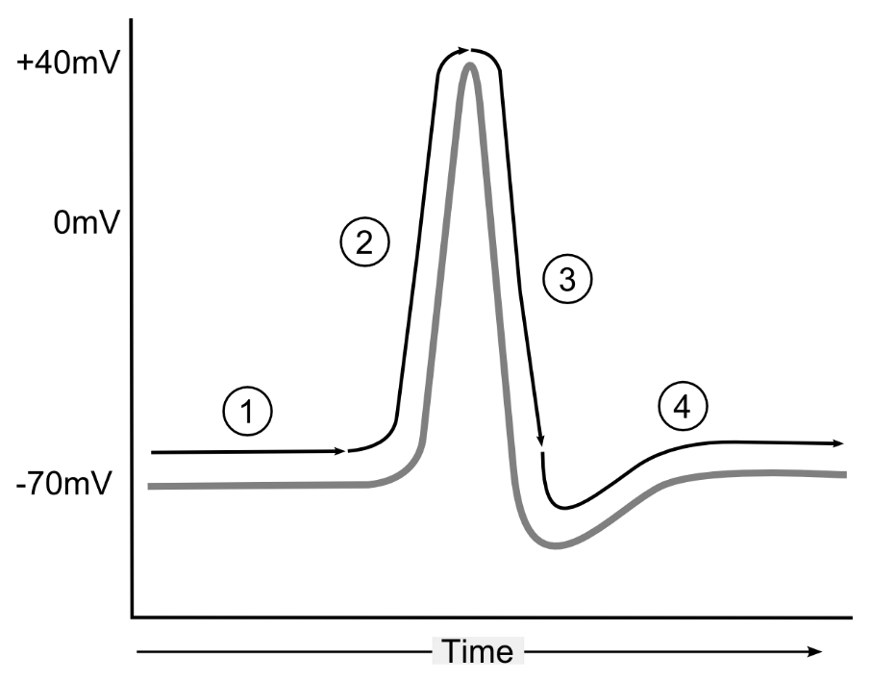

1. Which of the following correctly states what is happening at labels 2 and 3 on the diagram?
2. Sodium gates open at 2 and potassium gates open at 3.
3. Sodium gates close at 2 and potassium gates open at 3.
4. Sodium gates open at 2 and hyperpolarisation occurs at 3.
5. Potassium gates open at 2 and sodium gates close at 3.
6. The best explanation for the Founder Effect is that:
7. large populations are more affected by natural disasters than small

populations.

1. populations migrating to a new environment will increase the number of alleles in their gene pool.
2. in small populations, a particular allele may have an unusually high frequency.
3. allele frequencies change because some alleles are more affected by an environmental change than others.
4. Which of the following represents an example of a chromosomal mutation?
5. Sickle cell anaemia
6. Cystic fibrosis
7. Tay-Sachs Disease
8. Down syndrome

Question 10 refers to the diagram depicting DNA profiling below.

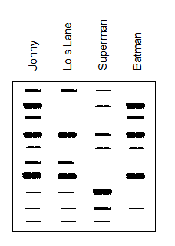

1. Which of the individuals are related to Johnny, based on the evidence in the profile?
2. Lois Lane only.
3. Batman only.
4. Lois Lane and Batman.
5. Lois Lane and Superman.
6. The main limitation of potassium-argon dating is that
7. it can only be used to date fossils over the age of 2 million years.
8. it cannot be used to date fossils earlier than 100,000 years old.
9. it can only date sedimentary rocks.
10. it can only date organic substances.

Question 12 refers to the illustration below.

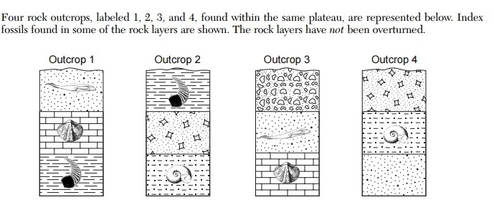

1. Using the method of stratigraphy, which of the following statements regarding the ages of the sedimentary rock layer outcrops is correct?
2. Outcrop 1 is the oldest, Outcrop 2 is younger than 4.
3. Outcrop 4 is the oldest, Outcrop 3 is younger than 1.
4. Outcrop 2 is the oldest, Outcrop 3 is younger than 1.
5. Outcrop 3 is the oldest, Outcrop 1 is younger than 4.

Questions 13 and 14 refer to the diagram below of spinal reflex arc.

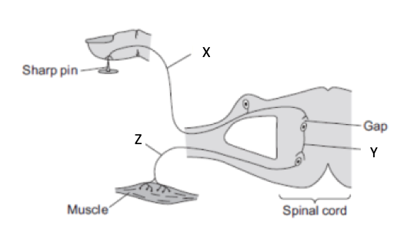

1. The structures labeled X and Y are
2. X: Dorsal Root Ganglion Y: Motor Neuron
3. X: Sensory Neuron Y: Connector Neuron
4. X: Dorsal Root Y: Sensory Neuron
5. X: Spinal Nerve Y: Motor Neuron
6. If the area labelled X was severed, the result would be that the person is
7. unable to move voluntarily but still able to feel a stimulus.
8. unable to feel a stimulus and is unable to move voluntarily.
9. able to respond in a reflex manner but the brain is not made aware of the stimulus.
10. unable to perform a reflex response but able to move voluntarily.
11. Which of the following accounts for variation within a population of the same species?
12. Mutation and random assortment.
13. Random fertilisation and the founder effect.
14. Isolation and migration.
15. Natural selection in small populations.
16. Fever occurs due to
17. a viral infection.
18. the hypothalamus resetting the body’s thermostat.
19. the medulla resetting the body’s thermostat.
20. a bacterial infection.
21. Early symptoms of Parkinson’s Disease are
22. muscle wasting and tremor.
23. uncontrolled movements and swelling of joints.
24. muscle tremors and a shuffling gait.
25. slow speech patterns and memory loss.
26. Jason has been feeling unwell and goes to his doctor for a diagnosis. He describes his symptoms to the doctor and they include weight loss, fatigue, sweating, anxiety, and rapid heartbeat. Jason is most likely suffering from
27. Diabetes mellitus Type 1.
28. Hashimoto’s disease.
29. Alzheimer’s disease.
30. Grave’s disease.
31. When comparing the nervous and endocrine systems, which of the following pairings is correct?

|  |  |  |  |
| --- | --- | --- | --- |
|  | **Characteristic** | **Nervous System** | **Endocrine System** |
| (a) | Nature of message | Chemical | Electrochemical |
| (b) | Type of response | Local and specific | General and widespread |
| (c) | Time taken to respond | Very slow | Very fast |
| (d) | Duration of response | Long lasting | Brief |

1. Sharon was involved in a car accident, her head colliding with the airbag with great force. She survived the crash, but found it difficult to initiate movement. This dysfunction is most likely due to damage to her:
2. cerebellum.
3. spinal cord at the lumbar level.
4. motor cortex.
5. sensory cortex.

Question 21 refers to the image below of the embryos of several different vertebrates.

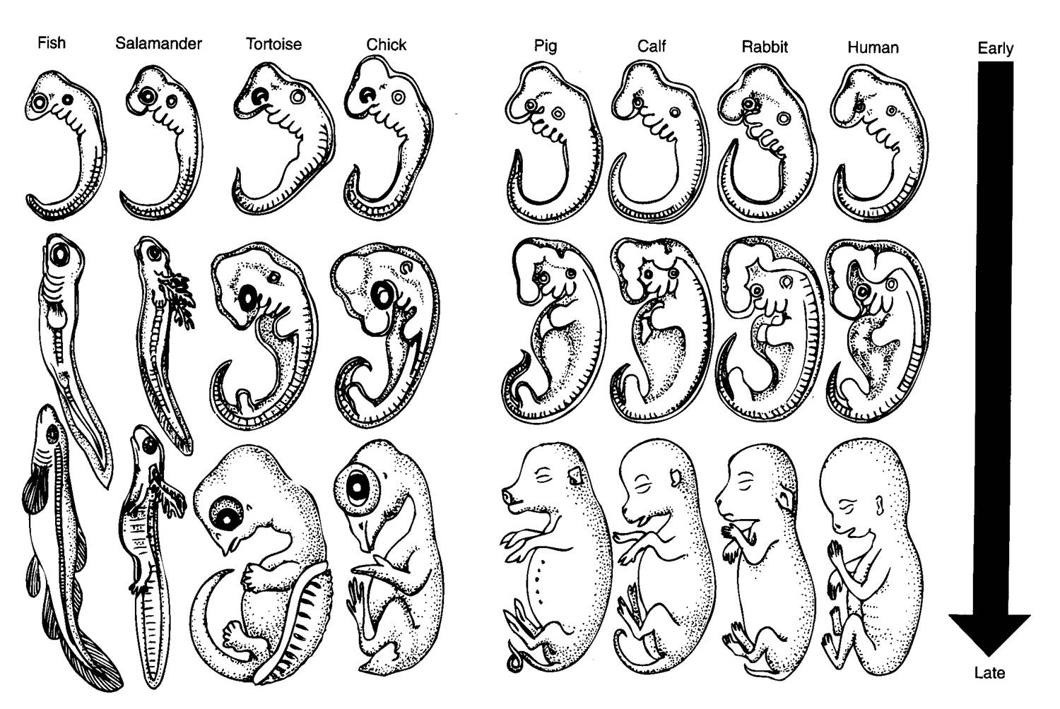

1. The two vertebrates that have the most closely related ancestor are the:
2. human and chick.
3. human and calf.
4. fish and salamander.
5. pig and rabbit.
6. Which of the following is an example of natural passive immunity?
   1. Antibodies passed through breast milk
   2. Vaccinations
   3. Becoming infected with the disease
   4. Being injected with antibodies
7. Which of the following would be a **correct** example of ‘positive feedback’ in homeostasis?
   1. Shivering when internal temperature is too low.
   2. Having a drink when you feel thirsty.
   3. Breathing faster when your body detects increased blood CO2.
   4. Uterine contractions during child birth.
8. Homo habilis:
9. demonstrated little prognathism and had a very small brain.
10. had a complex tool culture and lived in home bases.
11. had very large canine teeth to tear meat.
12. exhibited an upright stance and lived in Africa.
13. According to several theories about the evolution of hominids, bipedalism evolved due to:
14. disease epidemics that occurred due to increased population density.
15. rising sea levels that isolated some populations.
16. a shift from predominantly forest surroundings to grasslands.
17. an increase in the number of other species inhabiting the trees.
18. Which of the following is a hominid evolutionary trend that resulted from an increase in the complexity of their anatomy and brain size?
19. Increased prognathism.
20. Increased temporal filling.
21. Development of claws.
22. Decreased number of cusps in the molar teeth.
23. DNA is ‘cut’ into pieces at recognition sites before it can be used in recombinant DNA technology. The enzyme(s) used to combine the cut pieces with the host DNA is/are called:
24. RNA polymerase.
25. Restriction enzymes.
26. DNA ligase.
27. Phages.
28. An antigen is:
29. a protein that breaks down cell walls of bacteria.
30. a disease causing organism.
31. a protein produced by lymphocytes to enhance macrophage activity.
32. any substance capable of producing an immune response.
33. During the Industrial Revolution in Britain there was an increase in production of pollution, following this, the population of dark variety of the peppered moth increased. This increase in the dark form was due to:
34. dark moths being resistant to pesticides.
35. a change in the population of birds.
36. an increase in the mutation rate.
37. a change in selection pressure.
38. A researcher for a drug company was testing a new type of antibiotic on mice who were infected with a species of bacteria known to be killed by the antibiotic. He gave 5 mg once a day to half of the mice and 10 mg to the other half of mice. The mice who received the 10 mg of antibiotic recovered fully from their infection.

The independent and dependent variables are:

1. the mice and the antibiotic respectively.
2. the dose of antibiotic and the recovery from the infection respectively.
3. the recovery from the infection and the dose of antibiotic respectively.
4. 5 mg of antibiotic and 10 mg of antibiotic respectively.

**End of Section One**

**Section Two: Short answer 50% (100 Marks)**

This section has **nine** questions. Answer **all** questions. Write your answers in the spaces provided.

Supplementary pages for planning/continuing your answer to questions are provided at the end of this Question/Answer booklet. If you use these pages to continue an answer, indicate at the original answer where the answer is continued, i.e. give the page number.

Suggested working time: 90 minutes.

________________________________________________________________________

**Question 31 (7 marks)**

Parts (a) and (b) refer to the image of tools shown below.

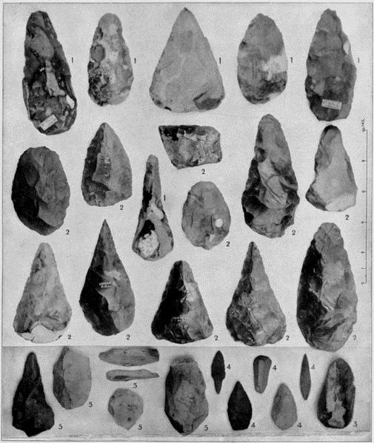

1. Name the species which is associated with these tools. (1 mark)

___________________________________________________________________

1. Name and describe the tool culture of this species, explaining how the tools that they produced contributed to their lifestyle. (6 marks)

___________________________________________________________________

___________________________________________________________________

___________________________________________________________________

___________________________________________________________________

___________________________________________________________________

___________________________________________________________________

___________________________________________________________________

**Question 32 (13 marks)**

Measles is a very contagious viral illness that causes a skin rash and fever. It can potentially cause serious, sometimes fatal, complications including pneumonia.

Measles is rare in Australia because of the widespread use of the measles vaccine. Vaccination is important because people travelling from overseas can carry the virus. The incidence of cases of measles in Australia has increased in the last 3 years, causing concern for health authorities.

1. Explain the body’s cell mediated response to vaccines, to enable people who are exposed to diseases such as measles to remain unaffected. (5 marks)

___________________________________________________________________

___________________________________________________________________

___________________________________________________________________

___________________________________________________________________

___________________________________________________________________

___________________________________________________________________

___________________________________________________________________

___________________________________________________________________

___________________________________________________________________

___________________________________________________________________

___________________________________________________________________

___________________________________________________________________

1. Explain **two** possible reasons for the sudden increase in the incidence of measles cases in Australia. (2 marks)

___________________________________________________________________

___________________________________________________________________

___________________________________________________________________

___________________________________________________________________

1. Describe **two** ethical concerns about the use of vaccines. (2 marks)

___________________________________________________________________

___________________________________________________________________

___________________________________________________________________

___________________________________________________________________

A student received the vaccine for measles and then three months later was exposed to the measles pathogen.

1. On the axes below, draw and clearly label the antibody response for a student when they received the vaccine and when they were subsequently exposed to the pathogen. (4 marks)

Antibodies

Time

**Question 33 (12 marks)**

Some fossils of Aboriginal people were found in Victoria, very close to a river. The method used to date the remains was Carbon-14 dating.

1. Explain the process of Carbon-14 dating. Include in your response, how to calculate the age of the specimen using this technique. (5 marks)

___________________________________________________________________

___________________________________________________________________

___________________________________________________________________

___________________________________________________________________

___________________________________________________________________

___________________________________________________________________

___________________________________________________________________

___________________________________________________________________

___________________________________________________________________

___________________________________________________________________

___________________________________________________________________

___________________________________________________________________

1. The fossil record is incomplete and does not account for all of the organisms that have existed. Describe **three** reasons for the incomplete nature of the fossil record. (3 marks)

_______________________________________________________________________________________________________________________________________________________________________________________________________________________________________________________________________________________________________________________________________________

______________________________________________________________________________________________________________________________________

Part (c) and (d) refer to the diagram below.

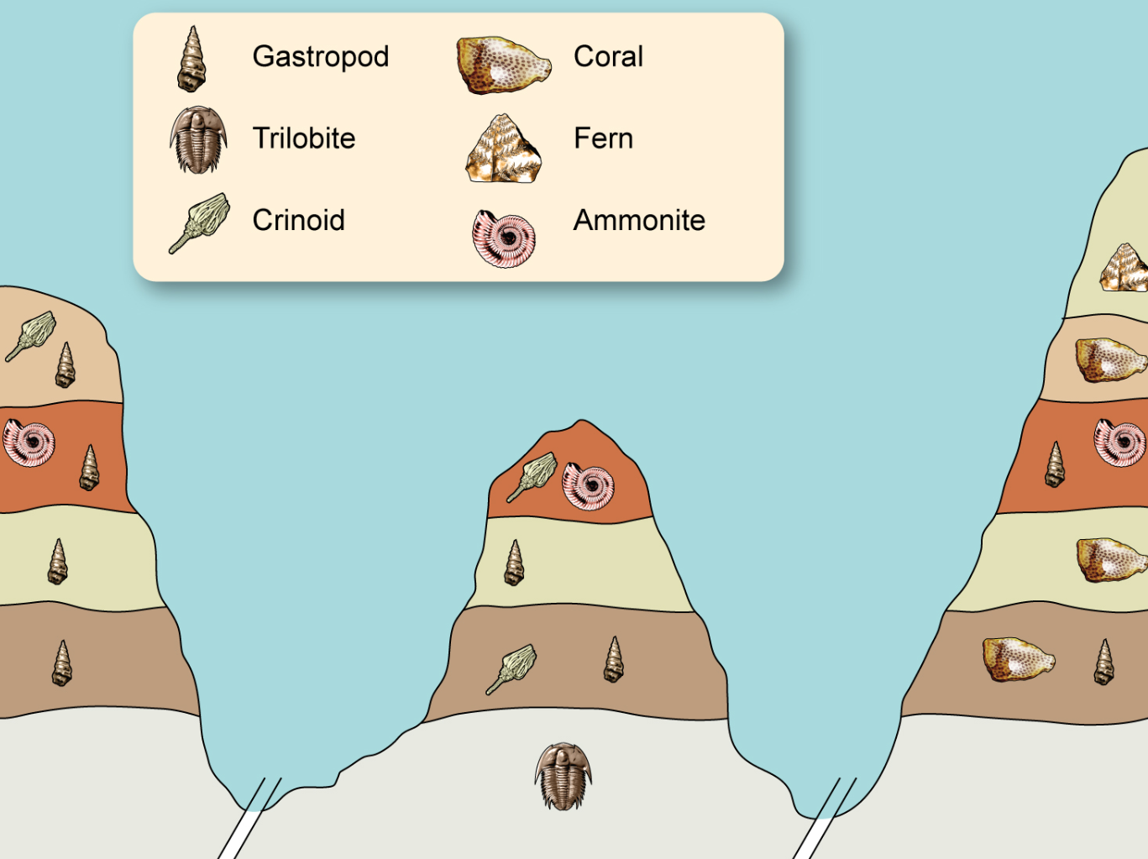

1. Which is the most recently evolved fossil out of the ammonite and crinoid? Provide a reason for your choice. (2 marks)

_________________________________________________________________________________________________________________________________________________________________________________________________________

1. Explain whether the gastropod would be a suitable organism to be used as an index fossil. (2 marks)

_________________________________________________________________________________________________________________________________________________________________________________________________________

**Question 34 (6 marks)**

The diagram below shows the glands of the endocrine system.

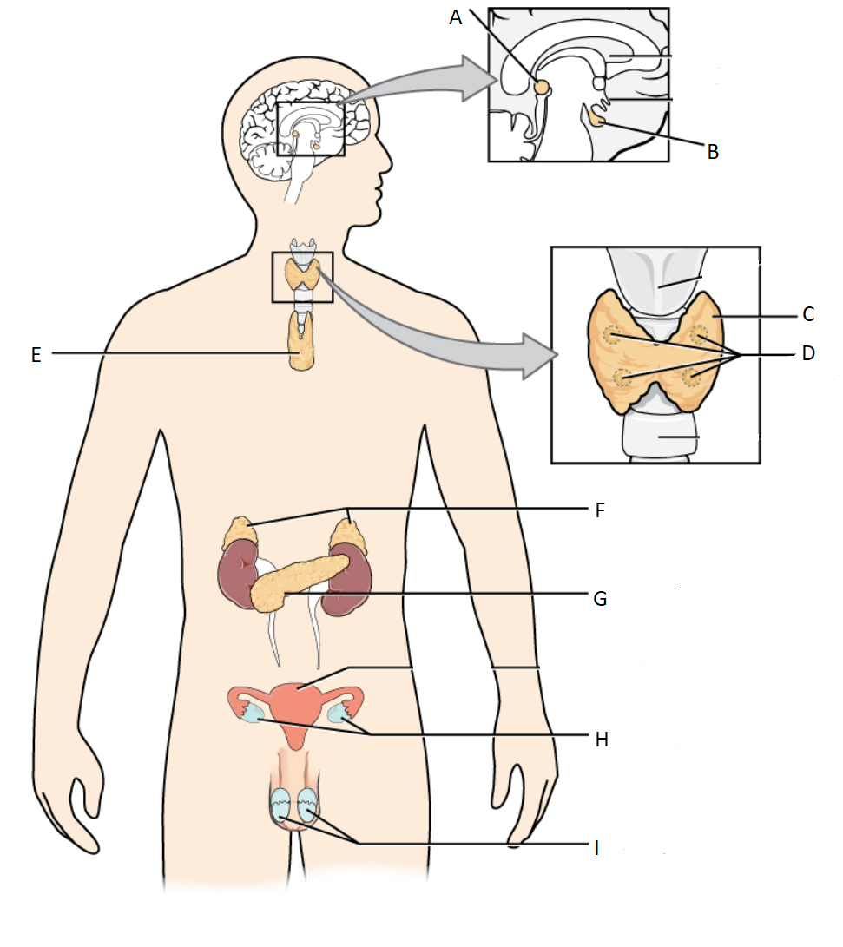

1. Name the endocrine organ at the location below: (1 mark)

C:_________________________________________________________________

1. Provide an example of **one** hormone produced by the gland at location D. (1 mark)

___________________________________________________________________

1. Cortisol and glucagon are both hormones that work to increase the levels of glucose in the blood. However, they differ in their mode of action. Cortisol is a lipid soluble hormone and glucagon is a water-soluble hormone. In the table below contrast the mode of action of these two hormones. (4 marks)

|  |  |
| --- | --- |
| Cortisol | Glucagon |
|  |  |

**Question 35 (11 marks)**

Human mitochondrial DNA (mtDNA) contains 37 genes, all of which are involved in protein synthesis and cellular respiration. Comparison of mitochondrial DNA has allowed scientists to track differences in mtDNA sequences between human groups to show migration patterns around the world of our original ancestors. These differences in sequences are due to mutations.

* + - * 1. How is mitochondrial DNA inherited? Why does this feature make it suitable for tracking human movement over time? (3 marks)

____________________________________________________________________________________________________________________________________________________________________________________________________________________________________________________________________________

______________________________________________________________________________________________________________________________________

Nuclear DNA is also prone to mutation. These mutations can be somatic or germline.

* + - * 1. Describe **one** possible consequence of acquiring a somatic mutation. (2 marks)

_________________________________________________________________________________________________________________________________________________________________________________________________________

Biochemical comparative protein studies can also provide evidence for evolution. Ubiquitous proteins such as cytochrome C, can be used for comparison of different species to determine how closely related to each other they are.

Parts (c) and (d) refer to the table below showing the differences in amino acids in the cytochrome C protein sequence between humans and other species of animals.

|  |  |
| --- | --- |
| Species compared with humans | Number of differences in amino acid sequence compared with human cytochrome C |
| Chimpanzee | 0 |
| Gorilla | 0 |
| Rhesus monkey | 1 |
| Rabbit | 9 |
| Tuna fish | 21 |

* + - * 1. Describe how this data can provide evidence for evolution. (3 marks)  
           ______________________________________________________________________________________________________________________________________________________________________________________________________

_________________________________________________________________________________________________________________________________________________________________________________________________________

* + - * 1. Draw a phylogenetic tree that depicts the relationships between the species in the table. Include *Homo sapiens* in you diagram. (3 marks)

**Question 36 (17 marks)**

Nerve impulse transmission is dependent on neurotransmitters such as acetylcholine allowing communication between neurons. Many factors can affect the effectiveness of this transmission.

1. Use an annotated diagram to describe, in as much detail as possible, how impulses are transmitted between neurons at the synapse. (6 marks)

Julia was walking to her car in a shopping centre carpark. She was concentrating so much on her phone that she didn’t realise that she had walked into the middle of the road. A driver sounded their horn so that she would move out of the way. It startled her and she dropped the phone. Her heart started to race and she found that she was sweating.

1. Name the division of the nervous system that was causing Julia’s responses and describe **two** responses, other than those stated in the question, that she would have experienced. (3 marks)

___________________________________________________________________

______________________________________________________________________________________________________________________________________

Multiple Sclerosis (MS) is considered an autoimmune disease. It causes demyelination (loss of myelin) within the brain and spinal cord.

1. Describe the role of myelin within the nervous system. (2 marks)

___________________________________________________________________

___________________________________________________________________

___________________________________________________________________

1. Describe the effect MS may have on a person’s reaction time and explain why this may place a person at risk of injury. (4 marks)

___________________________________________________________________

___________________________________________________________________

___________________________________________________________________

___________________________________________________________________

___________________________________________________________________

(e) Explain what is meant by the term ‘autoimmune disease’. (2 marks)

___________________________________________________________________

___________________________________________________________________

___________________________________________________________________

**Question 37 (15 marks)**

Diabetes mellitus is a serious chronic condition that has become one of the most prevalent lifestyle diseases in societies such as Australia and the USA, with approximately 280 Australians developing diabetes every day. (Source: Diabetes Australia; diabetesaustralia.com.au).

All types of diabetes are increasing in prevalence, with Type 1 accounting for 10% and Type 2 for 85% of all diabetes cases.

1. Compare and contrast the onset, causes and symptoms of diabetes types 1 and 2. (8 marks)

___________________________________________________________________

___________________________________________________________________

___________________________________________________________________

___________________________________________________________________

___________________________________________________________________

___________________________________________________________________

___________________________________________________________________

___________________________________________________________________

___________________________________________________________________

___________________________________________________________________

___________________________________________________________________

___________________________________________________________________

___________________________________________________________________

___________________________________________________________________

1. Describe **three** treatments available for diabetes mellitus Type 2. (3 marks)

___________________________________________________________________

___________________________________________________________________

___________________________________________________________________

___________________________________________________________________

___________________________________________________________________

1. Explain how a diabetic would need to adjust their insulin dose if they are planning to do some strenuous exercise. (2 marks)

___________________________________________________________________

___________________________________________________________________

___________________________________________________________________

___________________________________________________________________

1. Explain why a diabetic would inject insulin prior to eating a meal. (2 marks)

___________________________________________________________________

___________________________________________________________________

___________________________________________________________________

___________________________________________________________________

**Question 38 (10 marks)**

A researcher wanted to study the relationship between environmental temperature and the volume of sweat produced by young people in a controlled environment.

She recruited 20 healthy volunteers between the ages of 16-20 years. The volunteers were seated in a room initially at 22oC. The researcher gradually increased the temperature of the room and identified the volume of sweat produced by each volunteer in a 20 minute period at each temperature.

The average volume of sweat produced at each temperature is shown in the table below.

|  |  |
| --- | --- |
| **Temperature of the room (oC)** | **Volume of sweat (mL)** |
| 22 | 50 |
| 32 | 200 |
| 38 | 550 |
| 42 | 820 |
| 47 | 1270 |

1. Suggest a hypothesis for this experiment. (1 mark)

___________________________________________________________________

___________________________________________________________________

1. State the following variables; (2 marks)  
   * 1. Independent Variable: ____________________________________________
     2. Dependent Variable: _____________________________________________
2. Describe **three** variables, other than those mentioned above, that should have been controlled by the researcher. (3 marks)

___________________________________________________________________

___________________________________________________________________

___________________________________________________________________

___________________________________________________________________

1. Suggest **two** ways that this experiment could have been made more reliable.

(2 marks)

___________________________________________________________________

___________________________________________________________________

___________________________________________________________________

___________________________________________________________________

Sweating is a mechanism used by the body to maintain body temperature at a constant level.

1. If the researcher had also measured urine output, describe the trend in volume and concentration of urine produced as the room temperature increased. (2 marks)

___________________________________________________________________

___________________________________________________________________

**Question 39 (9 marks)**

A student is answering an exam question on the topic of osmoregulation.

The question asks, “*If osmotic pressure is low, describe the homeostatic mechanism that will cause the osmotic pressure to increase*”.

The student writes the following response, “*the hypothalamus will produce ADH inhibiting factor which will target the posterior pituitary gland and reduce the amount of ADH released*”.

(f) Explain why the student’s response is incorrect. (2 marks)

__________________________________________________________________

__________________________________________________________________

__________________________________________________________________  
  
 __________________________________________________________________

(g) Describe how the student should have answered this question. (7 marks)

__________________________________________________________________

__________________________________________________________________

__________________________________________________________________

__________________________________________________________________

__________________________________________________________________

__________________________________________________________________

__________________________________________________________________

__________________________________________________________________

__________________________________________________________________

__________________________________________________________________

__________________________________________________________________

__________________________________________________________________

**End of Section Two**

**Section Three: Extended answer 20% (40 Marks)**

This section contains **three** questions. You must answer **two** questions. Write your answers on the pages following Question 42.

Supplementary pages for planning/continuing your answers to questions are provided at the end of this Question/Answer booklet. If you use these pages to continue an answer, indicate at the original answer where the answer is continued, i.e. give the page number.

Suggested working time: 50 minutes.

________________________________________________________________________

Answer any **two** questions from Questions 40 to 42.

Indicate the questions you will answer by ticking the box next to the question. Write your

answers on the pages that follow.

**Question 40 (20 marks)**

Sam went on a hike in the bush, making sure he had a sufficient supply of water and food for the 6 hour journey. His blood pH must be maintained within narrow tolerance limits. However, if there is an increase in the carbon dioxide level in the blood, the pH decreases and respiratory acidosis could occur. This can lead to organ failure and can be life threatening.

1. Describe the homeostatic mechanism that would return the pH of the blood to within normal limits while Sam is hiking. In your response, explain why a person who is hyperventilating may be told to breathe into a paper bag. (8 marks)

The GPS system on his phone failed and, as a result, he lost his way back to his car. Sam realised that he would have to spend the night out in the open. The temperature dropped to 5oC overnight. Sam was found early the next morning safe and well, if not a little cold.

1. Name the receptors in Sam’s body that would recognise the change in external temperature. Describe what would have happened to his body temperature if it had rained during the night and he could not find shelter from the wind. (4 marks)

Sam had only planned to be out in the wilderness for 6 hours and did not prepare any extra food in case of an emergency. Once he had eaten the food that he packed, he only had some water and chewing gum left. Sam did not eat for 10 hours prior to being rescued. The paramedics checked his blood glucose level which was at a relatively normal value of 4.5mmol/L.

1. Explain how Sam was able to maintain normal blood glucose levels despite not eating for 10 hours. (8 marks)

**Question 41 (20 marks)**

An evolutionary trend is a pattern of directional change that occurs in several species over a long period of time.

1. Referring specifically to prognathism, size of brain case compared to body size, and dentition, describe the changes seen in the following Hominid species.

* *Paranthropus robustus*
* *Homo habilis*
* *Homo erectus*  (9 marks)

In 2015, palaeontologists uncovered fossilised remains of a new Hominid species *Homo naledi* in a complex cave network in South Africa. This species was identified to have legs and feet similar to *Homo sapiens* while having hands and a pelvis similar to *Australopithicus afarensis.* The *Homo naledi* specimens were dated as being between 36000 and 45000 years old.

1. Describe the features you would expect to see in the legs, feet, hands and pelvis of *Homo naledi*. (8 marks)
2. Name the dating method that was used to assign an age to the *Homo naledi* specimens and explain why this method was used. (3 marks)

**Question 42 (20 marks)**

The remains of two species of human ancestors were found within a five kilometre range of each other and were, for many years, thought to be of the same species. With the evolution of biotechnology techniques, scientists decided to check more thoroughly as there were some differences observed that were originally explained as general variation within the species.

1. Explain how mutations cause variation between members of the same species, and why these mutations can be advantageous. (5 marks)
2. Name and describe the techniques that scientists would have used to determine whether or not the human ancestors were of the same species given that very small amounts of DNA were able to be extracted from the remnants found. (10 marks)
3. Outline the process of speciation. (5 marks)

**End of Questions**

Question number: _____________________

________________________________________________________________________________________________________________________________________________________________________________________________________________________________________________________________________________________________________________________________________________________________________________________________________________________________________________________________________________________________________________________________________________________________________________________________________________________________________________________________________________________________________________________________________________________________________________________________________________________________________________________________________________________________________________________________________________________________________________________________________________________________________________________________________________________________________________________________________________________________________________________________________________________________________________________________________________________________________________

___________________________________________________________________________________________________________________________________________________________________________________________________________________________________________________________________________________________________________________________________________________________________________________________________________________________________________________________________________________________________________________________________________________________________________________________________________________________________________________________________________________________________________________________________________________________________________________________________________________________________________________________________________________________________________________________________________________________________________________________________________________________________________________________________

Question number: _____________________

________________________________________________________________________________________________________________________________________________________________________________________________________________________________________________________________________________________________________________________________________________________________________________________________________________________________________________________________________________________________________________________________________________________________________________________________________________________________________________________________________________________________________________________________________________________________________________________________________________________________________________________________________________________________________________________________________________________________________________________________________________________________________________________________________________________________________________________________________________________________________________________________________________________________________________________________________________________________________________

___________________________________________________________________________________________________________________________________________________________________________________________________________________________________________________________________________________________________________________________________________________________________________________________________________________________________________________________________________________________________________________________________________________________________________________________________________________________________________________________________________________________________________________________________________________________________________________________________________________________________________________________________________________________________________________________________________________________________________________________________________________________________________________________________

Question number: _____________________

________________________________________________________________________________________________________________________________________________________________________________________________________________________________________________________________________________________________________________________________________________________________________________________________________________________________________________________________________________________________________________________________________________________________________________________________________________________________________________________________________________________________________________________________________________________________________________________________________________________________________________________________________________________________________________________________________________________________________________________________________________________________________________________________________________________________________________________________________________________________________________________________________________________________________________________________________________________________________________

___________________________________________________________________________________________________________________________________________________________________________________________________________________________________________________________________________________________________________________________________________________________________________________________________________________________________________________________________________________________________________________________________________________________________________________________________________________________________________________________________________________________________________________________________________________________________________________________________________________________________________________________________________________________________________________________________________________________________________________________________________________________________________________________________

Question number: _____________________

________________________________________________________________________________________________________________________________________________________________________________________________________________________________________________________________________________________________________________________________________________________________________________________________________________________________________________________________________________________________________________________________________________________________________________________________________________________________________________________________________________________________________________________________________________________________________________________________________________________________________________________________________________________________________________________________________________________________________________________________________________________________________________________________________________________________________________________________________________________________________________________________________________________________________________________________________________________________________________

___________________________________________________________________________________________________________________________________________________________________________________________________________________________________________________________________________________________________________________________________________________________________________________________________________________________________________________________________________________________________________________________________________________________________________________________________________________________________________________________________________________________________________________________________________________________________________________________________________________________________________________________________________________________________________________________________________________________________________________________________________________________________________________________________

Question number: _____________________

________________________________________________________________________________________________________________________________________________________________________________________________________________________________________________________________________________________________________________________________________________________________________________________________________________________________________________________________________________________________________________________________________________________________________________________________________________________________________________________________________________________________________________________________________________________________________________________________________________________________________________________________________________________________________________________________________________________________________________________________________________________________________________________________________________________________________________________________________________________________________________________________________________________________________________________________________________________________________________

___________________________________________________________________________________________________________________________________________________________________________________________________________________________________________________________________________________________________________________________________________________________________________________________________________________________________________________________________________________________________________________________________________________________________________________________________________________________________________________________________________________________________________________________________________________________________________________________________________________________________________________________________________________________________________________________________________________________________________________________________________________________________________________________________

Question number: _____________________

________________________________________________________________________________________________________________________________________________________________________________________________________________________________________________________________________________________________________________________________________________________________________________________________________________________________________________________________________________________________________________________________________________________________________________________________________________________________________________________________________________________________________________________________________________________________________________________________________________________________________________________________________________________________________________________________________________________________________________________________________________________________________________________________________________________________________________________________________________________________________________________________________________________________________________________________________________________________________________

___________________________________________________________________________________________________________________________________________________________________________________________________________________________________________________________________________________________________________________________________________________________________________________________________________________________________________________________________________________________________________________________________________________________________________________________________________________________________________________________________________________________________________________________________________________________________________________________________________________________________________________________________________________________________________________________________________________________________________________________________________________________________________________________________

Question number: _____________________

________________________________________________________________________________________________________________________________________________________________________________________________________________________________________________________________________________________________________________________________________________________________________________________________________________________________________________________________________________________________________________________________________________________________________________________________________________________________________________________________________________________________________________________________________________________________________________________________________________________________________________________________________________________________________________________________________________________________________________________________________________________________________________________________________________________________________________________________________________________________________________________________________________________________________________________________________________________________________________

___________________________________________________________________________________________________________________________________________________________________________________________________________________________________________________________________________________________________________________________________________________________________________________________________________________________________________________________________________________________________________________________________________________________________________________________________________________________________________________________________________________________________________________________________________________________________________________________________________________________________________________________________________________________________________________________________________________________________________________________________________________________________________________________________

Question number: _____________________

________________________________________________________________________________________________________________________________________________________________________________________________________________________________________________________________________________________________________________________________________________________________________________________________________________________________________________________________________________________________________________________________________________________________________________________________________________________________________________________________________________________________________________________________________________________________________________________________________________________________________________________________________________________________________________________________________________________________________________________________________________________________________________________________________________________________________________________________________________________________________________________________________________________________________________________________________________________________________________

___________________________________________________________________________________________________________________________________________________________________________________________________________________________________________________________________________________________________________________________________________________________________________________________________________________________________________________________________________________________________________________________________________________________________________________________________________________________________________________________________________________________________________________________________________________________________________________________________________________________________________________________________________________________________________________________________________________________________________________________________________________________________________________________________

Question number: _____________________

________________________________________________________________________________________________________________________________________________________________________________________________________________________________________________________________________________________________________________________________________________________________________________________________________________________________________________________________________________________________________________________________________________________________________________________________________________________________________________________________________________________________________________________________________________________________________________________________________________________________________________________________________________________________________________________________________________________________________________________________________________________________________________________________________________________________________________________________________________________________________________________________________________________________________________________________________________________________________________

___________________________________________________________________________________________________________________________________________________________________________________________________________________________________________________________________________________________________________________________________________________________________________________________________________________________________________________________________________________________________________________________________________________________________________________________________________________________________________________________________________________________________________________________________________________________________________________________________________________________________________________________________________________________________________________________________________________________________________________________________________________________________________________________________

Question number: _____________________

________________________________________________________________________________________________________________________________________________________________________________________________________________________________________________________________________________________________________________________________________________________________________________________________________________________________________________________________________________________________________________________________________________________________________________________________________________________________________________________________________________________________________________________________________________________________________________________________________________________________________________________________________________________________________________________________________________________________________________________________________________________________________________________________________________________________________________________________________________________________________________________________________________________________________________________________________________________________________________

___________________________________________________________________________________________________________________________________________________________________________________________________________________________________________________________________________________________________________________________________________________________________________________________________________________________________________________________________________________________________________________________________________________________________________________________________________________________________________________________________________________________________________________________________________________________________________________________________________________________________________________________________________________________________________________________________________________________________________________________________________________________________________________________________

Question number: _____________________

________________________________________________________________________________________________________________________________________________________________________________________________________________________________________________________________________________________________________________________________________________________________________________________________________________________________________________________________________________________________________________________________________________________________________________________________________________________________________________________________________________________________________________________________________________________________________________________________________________________________________________________________________________________________________________________________________________________________________________________________________________________________________________________________________________________________________________________________________________________________________________________________________________________________________________________________________________________________________________

___________________________________________________________________________________________________________________________________________________________________________________________________________________________________________________________________________________________________________________________________________________________________________________________________________________________________________________________________________________________________________________________________________________________________________________________________________________________________________________________________________________________________________________________________________________________________________________________________________________________________________________________________________________________________________________________________________________________________________________________________________________________________________________________________